**Chapter 1: Develop Azure compute solutions (~~20-25~~25-30%):**

**What is Azure Compute?**

Access **cloud computer** capacity, virtualisation and scale on demand – and only pay for the resources you use. Whether you are building new applications or deploying existing ones, **Azure compute** provides the infrastructure you need to run your apps. Tap into **compute** capacity in the **cloud** and scale on demand.

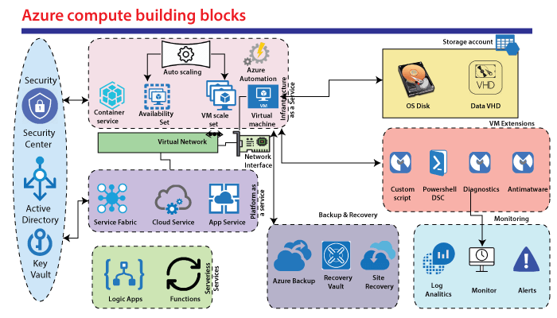

**What is Virtual Machine (VM)?**

It is virtual environment that functions as a virtual computer system with its own CPU, memory, network interface and storage created on a physical hardware (located off- or on-premises).

A **virtual machine** (or “VM”) is an emulated **computer** system created using software. It uses physical system resources, such as the CPU, RAM, and disk storage, but is isolated from other software on the **computer.** These applications allow you to run multiple **VMs** on a single **computer.**

**Examples of Virtual Machine:**

* Virtual Box
* Vmware

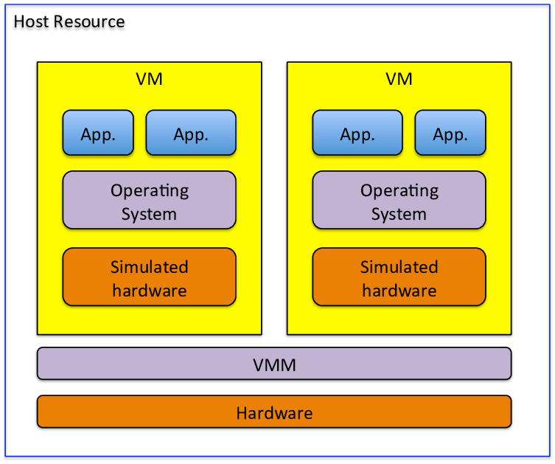

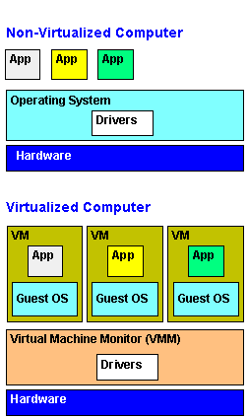

**Types of Virtual Machines:**

* Process Virtual Machine
* System Virtual Machine

**Process Virtual Machine:**

It allows to run a single process as an application on a host machine.

**Example:**

Java Virtual Machine (**JVM),** Wine Software [Linux]

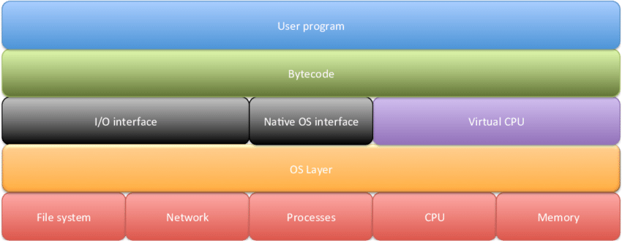

**Fig:** **Process Virtual Machine**

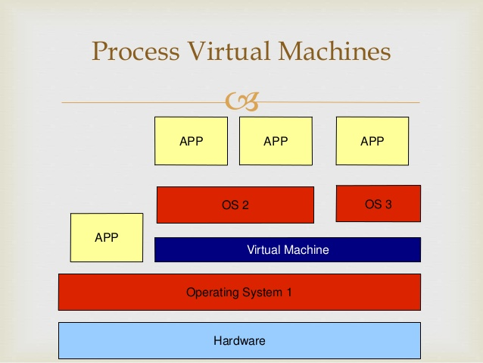

**System Virtual Machine:**

It is a fully virtualized VM designed to be a substitute for a physical machine. It runs on a different host machine by utilizing a hypervisor such as **VMware ESXI** to access the underlying machine’s resources.

**Example:**

VMWare, Xen, Virtual Box

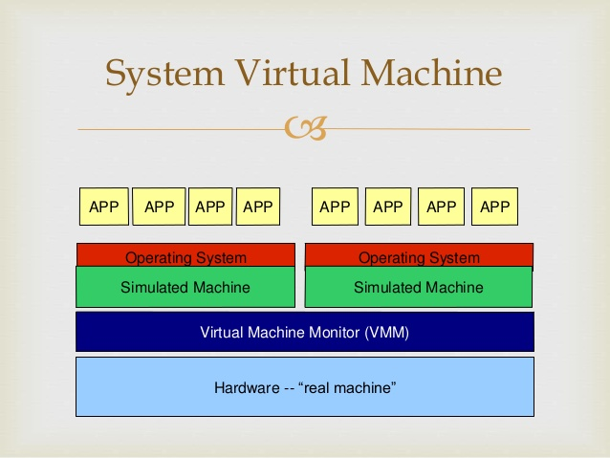

**What is mean by Virtualization?**

**Virtualization** is the process of creating a software-based, or virtual, representation of something, such as virtual applications, servers, storage and networks. It is the single most effective way to reduce IT expenses while boosting efficiency and agility for all size businesses.

**Types of Virtualization:**

* Client Virtualization
* Virtual Desktop Infrastructure (VDI)
* Application Virtualization

**Benefits (Or) Advantages of Virtual Machine:**

* They allow multiple operating systems (OS) environments to exist parallelly on the same machine.
* They empowers users to go beyond the limitations of hardware to achieve their goals.
* Using VMs ensures application provisioning, better availability, Easy Maintenance and recovery.

**Disadvantages of Virtual Machine:**

* Virtual machines are less efficient than real machines because they access the hardware indirectly. Running software on top of the host operating system means that it will have to request access to the hardware from the host. That will slow the usability.
* When several virtual machines are running on the same host, performance may be hindered [braked] if the computer it’s running on lacks sufficient power. Your virtual machine still uses the resources of your host machine. The more powerful the host computer, the more quickly the virtual machine will run.
* It takes several minutes to boot up.

**Challenges in using a Virtual Machine:**

* When Simultaneous VMs run on a host computer, each can introduce an unstable performance depending on the workload of the system.
* The efficiency of VMs fails short compared to Physical machines
* Licensing models of virtualization solutions can be tricky. They can result in huge upfront investment costs due to additional hardware requirements.
* Due to the increasingly high number of branches on VM and cloud deployments, security is added concern.
* For every virtualization solution, the infrastructure setup is complex. Small business have to hire experts to deploy these solutions successfully.
* VMs pose data security threats when multiple users try to access the same or different VMs on the same physical host.
* If not managed properly, the snapshots and backups of VMs can quickly consume storage space.

**Are Virtual Machines Are Safe?**

Virtual Machines are an isolated environment from the physical operating system, so you can run potentially dangerous stuff, such as malware, without fear of compromising your main OS.

They are safe environment, but there are exploits against virtualization software, allowing malware to spread to the physical system.

That’s why you should update your virtualization software when needed.

**What is meant by VMware?**

**VMware** is a virtualization and cloud computing software provider based in Palo Alto, California. Which is founded in the year of 1998. With **VMware** server virtualization, a hypervisor is installed on the physical server to allow for multiple Virtual Machines (VMs) to run on the same Physical server.

Simply put, **VMware** develops virtualization software. Virtualization Software creates an abstraction layer over computer hardware that allows the hardware elements of a single computer – processors, memory, storage, and more – to be divided into multiple virtual computers, commonly called virtual machines (VMs)

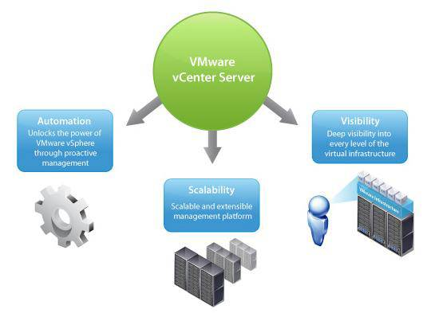

**Benefits of VMware:**

* Greater IT Efficiencies
* Reduced Operating **costs**
* Faster Workload Deployment
* Increased Application Performance
* Higher Server Availability
* Eliminated Server Sprawl and complexity

**What is mean by Hypervisor?**

It is also known as a virtual machine monitor or VMM, is software that creates and runs virtual machines (VMs).

A **Hypervisor** allows one host computer to support multiple guest VMs by virtually sharing its resources, such as memory and processing.

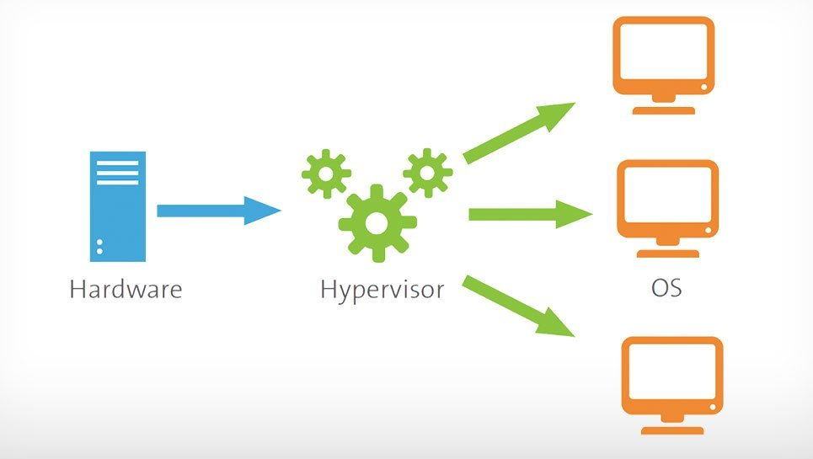

**Examples:**

* Hyper-V
* VMware

**Why is hypervisor needed?**

The **hypervisor** drives the concept of virtualization by allowing the physical host machine to operate multiple virtual machines as guests to help maximize the effective use of computing resources such as memory, network bandwidth and CPU cycles.

**What is meant by vSphere?**

**VMware vSphere** is the name of **VMware’s** server virtualization product. It’s formerly known as **VMware** infrastructure, and it consists of **ESXi,** a Type 1 hypervisor, **VCenter** Server and a few other important features to ensure virtual servers are up and running.

**What is the purpose of vSphere?**

**vSphere** is a **VMware** cloud computing platform for virtualization. It includes an updated vCenter Configuration Manager, as well as vCenter Application Discovery Manager, and the ability of vMotion to move more than one virtual machine at a time from one host server to another.

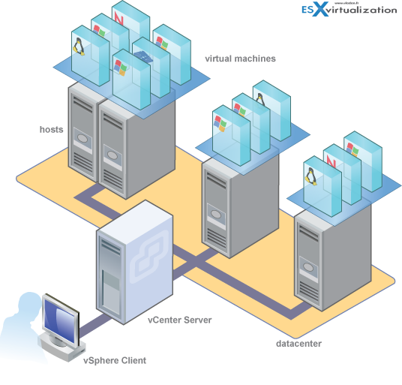

**Section 1: Implementing IaaS Solutions**

**Provision VMs:**

**What is mean by Virtual Machine Provisioning?**

**Virtual Machine Provisioning,** or virtual server **provisioning,** is a system management process that creates a new **Virtual Machine (VM)** on a physical host server and allocates computing resources to support the **VM.** This generic **VM** is loaded from storage (usually the corporate SAN [Storage Area Network]) to the desired host server.

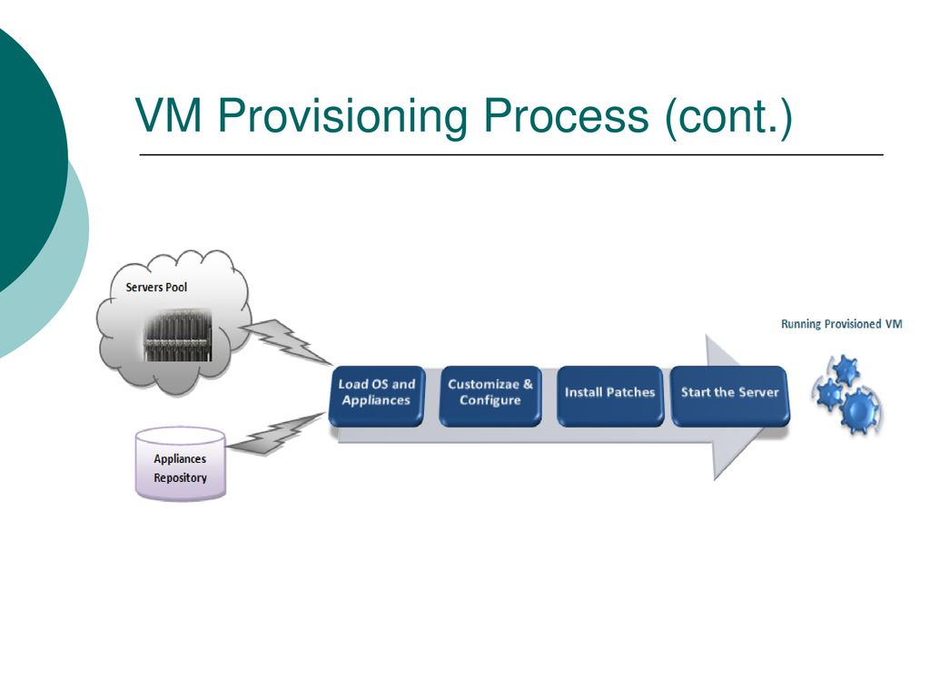

**What is mean by Virtual Provisioning?**

**Virtual Provisioning** is a strategy for efficiently managing space in a **Storage Area Network (SAN)** by allocating physical storage on an “as needed” basis. **Virtual provisioning** gives a host, application or file system the illusion that it has more storage than is physically provided.

Virtual Provisioning can reduce power and cooling costs by cutting down on the amount of

Idle storage devices in the array.

**Benefits of Virtual Provisioning:**

* Increasing Storage Utilization. Eliminate the need to dedicate full capacity upfront while still providing application users with the capacity they need for future growth.
* Enhance Application Uptime for Improved Business Continuity.
* Simplify Storage Capacity Management.

**Why do we need Virtual Provisioning?**

It is designed to simplify storage administration by allowing storage administrators to meet requests for capacity on-demand. **Virtual Provisioning** gives a host, application or file system the illusion that it has more storage than **is** physically provided.

**Types of Virtual Provisioning:**

* **Create VMs from a Blank Virtual Hard Disk**
  + You Create a VM and install an operating system from an .iso image, removable media, or from a network boot with a PXE Server.
* **Create VMs from an Existing Virtual Hard Disk**
  + You Create a VM from a virtual hard disk in the VMM library. We recommend a VHD that’s been generalized with Sysprep.
* **Clone a VM from an existing VM**
  + Clone an existing VM in the VMM library to create a new one. We recommend you clone a VM that’s been generalized with Sysprep.
* **Create a VM from a template**
  + Create VMs with consistent settings configured in a VM template. VM templates are XML objects stored in the VMM library. They can be used to control and restrict VM settings available to self-service users. Template settings include the guest operating system profile, a hardware profile, and one or more VHDs that can be used to create a new VM.
* **Create a VM in a service deployment**
  + In VMM you can create services that are logical grouping of VMs that are configured and deployed as single entity. A Single tier service includes a Single VM. Multi-tier Services have multiple VMs.
* **Rapidly provision a VM using storage area network (SAN) copy**
  + Deploy a VM using SAN copy abilities such as snapshot and clone. You can rapidly provision standalone VMs, or VMs that are provisioned in a service.

**What is mean by VMM Library?**

The **VMM library** is a file share that includes a catalog of resources that are used to deploy virtual machines and services in the **VMM** fabric. Non-file-based resources such as virtual machine templates and service templates that are used to create VMs and services.

**What is Virtual Machine Manager?**

It is part of the System Center suite, used to configure, manage and transform traditional datacenters, and helping to provide a unified management experience across on-premises, service provider, and the Azure cloud, VMM capabilities include the following:

* Data center
* Virtualization hosts
* Networking
* Storage
* Library Resources

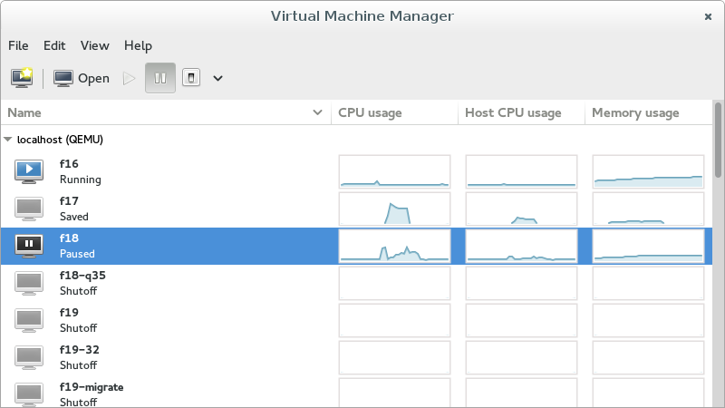

**Deploy VMs in the VMM fabric from a blank virtual hard disk:**

**Before Start:**

* You must be an Administrator or Delegated Administrator on the VMM server, or a self-service user.
* If you’re a self-service you need **Deploy** permissions with the **Store and re-deploy** action assigned. You must deploy the VM to a private cloud, and then store it in the library.
* You can only customize static IP address settings if you create a VM from a VM template.
* You can use VMM to configure the availability settings for the virtual machine.

**Create VM:**

Select **VMs and Services -> Create Virtual Machine -> Create Virtual Machine.**

In **Create Virtual Machine Wizard -> Select Source**, click **Create the new virtual machine with a blank virtual hard disk -> Next**.

In **Identity,** specify the VM name and an optional description, In the **Generation** box, select **Generation 1** or **Generation 2.** Then click **Next.**

In **Configure Hardware** page, either select the profile that you want to use from the **Hardware profile** list, or configure the hardware settings manually. The hardware settings displayed will differ depending on whether you’re deploying a generation 1 or generation 2 machine. Then click **Next**

If you want to store the virtual machine in the VMM library before you deploy it to a host, use of one of the blank virtual hard disks that are provided by default in the VMM library. Click the VHD in **Bus Configuration**. Click **Use an existing virtual hard disk -> Browse** and select a blank hard disk.

If the virtual machine is a generation 1 that boots from the network to install an operating system, in **Network Adapters,** use the legacy network adapter type.

In **Select Destination** page, specify how the virtual machine should be deployed – in a private cloud, on a host, or stored in the library.

**Compatibility:** If you want to deploy the virtual machine to a private cloud, select a capability profile that is available to the private cloud.

**Bus Configuration:** If you want to install an operating system from a DVD or an .iso image, ensure there is a virtual DVD drive that is configured to use an unavailable option such as the **Existing ISO Image file** option. If you want to use an ISO Image file, the file must be present in the VMM library.

**How to Deploy a VM:**

**Expected Utilization:** Expected Utilization for a VM created from a blank VHD is based on standard defaults. VMM updates host suggestions and ratings in response to modifications made to the expected virtual machine utilization.

**Make this VM highly available:** With this option selected, only hosts that are located in a cluster are available for selection.

**Details:** It Indicates the status of the host, the operating system, and the type and status of the virtualization software.

**Rating Explanation:** Provides an explanation if a host received a zero rating.

**SAN Explanation** or **Deployment and Transfer Explanation:** Lists any factors that make a storage area network (SAN) transfer unavailable. VMM does not recognize a virtual machine that is stored on a SAN as available for deployment by using SAN transfer, if the virtual machine was stored directly in the library when it was created or added to the library during a library refresh. To avoid this issue, deploy the virtual machine to a host by using a LAN transfer, and then store the virtual machine in the same VMM library, library share, and logical unit number (LUN).

The **Deployment and Transfer Explanation** tab provides an explanation if fast file copy cannot be used. Fast file copy is based on the Windows Offloaded Data Transfers (ODX).

In **Configure Settings,** review the VM settings. Either accepts the default VM path on the host or specify a different location. You can optionally select to **Add this path to the list of default virtual machine paths on the host.** In **Machine Resources** accept the default values for the VHD, or modify as required.

In **Select Networks,** if it appears, optionally select the network settings, and click **Next.**

In **Add Properties,** configure the action to take when the host starts or stops, and the operating system that you will install on the VM. Then click **Next.**

**How to Deploy the VM in a Private Cloud:**

In **Select Cloud** select the private cloud on which you want to place the virtual machine. If you are connected as an Administrator, you can select the host on which the virtual machine should be deployed in the private cloud. Cloud Suggestions are based on a 0-5 star rating.

Check **“How to Deploy a VM” [given above]**

In **Summary,** confirm the settings, and click **Create.** Confirm that the VM was created in **VMs and Services -> Clouds,** and select the cloud. The virtual machine appears in the **VMs** pane.

**How to Deploy the VM on a Host:**

In **Select Host,** view the ratings, click the host which you want to deploy the VM, and click **Next**. The host suggestions are based on a 0-5 star rating.

Check **“How to Deploy a VM” [given above]**

On the **Summary** page, confirm the settings, and then click **Create.**

**Store the VM in the Library:**

* In **Select Library Server,** click the library server that you want to use, then click **Next,**
* In **Select Path,** specify the library share location to store the virtual machine. Click **Browse** to select a library share and an optional folder location, click **OK,** and then click **Next.**
* On the **Summary** page, confirm the settings, and then click **Create.**
* To confirm that the virtual machine was created, in the **Library** workspace, in the **Library** pane, expand **Library Servers,** expand the library server where you stored the virtual machine, and then click **Stored Virtual Machines and Services.** The stored virtual machine appears in the **Physical Library Objects** pane.

**Deploy VMs in the VMM fabric from an existing virtual hard disk:**

**Before Start:**

* You must be an Administrator or Delegated Administrator on the VMM server, or a self-service user.
* If you’re a self service you need **Deploy** permissions with the **Store and re-deploy** action assigned. You must deploy the VM to a private cloud, and then store it in the library.
* The VHD you want to use must be stored in the VMM library.
* Use a VHD that has been generalized using Sysprep. If you don’t the identity of the cloned VM will be the same as the source VM, and issues might occur if you turn them on together.

**Clone VMs from another VM in the VMM fabric:**

**Before Start:**

* To Complete the steps you must be an Administrator or Delegated Administrator on the VMM server, or a self-service user.
* When you clone a virtual machine, the existing virtual machine is not deleted. We recommend that you clone a virtual machine that has been prepared and generalized with the Sysprep tool. If you do not use a generalized virtual hard disk, the identity of the new virtual machine will be the same as the source. Issues might occur if you turn on two virtual machines with the same identity at the same time.
* You can clone a virtual machine that is deployed on a host. The machine can be online, stopped, or in a saved state.
* You can clone a VM that is stored in the VMM library,
* The option to use differencing disk optimizations is automatically applied when you deploy the virtual machine on a host, if a base disk exists on that host.
* If you’re a self-service user you need **Deploy** permissions with the **Store** **and re-deploy** action assigned. You must first deploy the VM to a private cloud, and then store it in the library.

**Create a VM:**

* Click **VMs and Services -> Create Virtual Machine -> Create Virtual Machine.**
* In **Create Virtual Machine Wizard**-> **Select Source** , click **Use an existing virtual machine, VM template, or virtual hard disk-> Browse**, Select an existing VM.
* In **Select Source**, click **Next.**
* In **Configure Hardware,** optionally configure any available settings. Then click **Next.**
* In **Select Destination** page, specify how the virtual machine should be deployed – in a private cloud, on a host, or a stored in the library.

**Deploy VMs with rapid provisioning using SAN copy in the VMM fabric:**

* This method used for deploying new virtual machines to storage arrays without needing to copy VMs over the network. VMM uses the SAN infrastructure for cloning VMs, with a VM template to customize the guest operating system.
* You can use rapid provisioning to deploy standalone VMs, and VMs that are deployed as part of a service.
* You create a SAN copy-capable template from a virtual hard disk (VHD) that resides on a storage logical unit that supports SAN copy through cloning or snapshots.
* When you create a VM by using the SAN copy-capable template, VMM quickly creates a read-write copy of the logical unit that contains the VHD, and places the virtual machine files on the new logical unit. When VMM deploys a virtual machine by using rapid provisioning through SAN Copy, VMM uses a SAN transfer instead of a network transfer. During a SAN transfer, a SAN copy of the logical unit that contains the virtual machine is created and is assigned to the destination host or host cluster. Because the files for a virtual machine are not actually moved over the network when you transfer a virtual machine over a SAN, it is much faster than a transfer over a standard network.
* You can use either of the following methods to Create a SAN copy-capable template.
  + Create a SAN-copy capable template from a new VM
  + Create a SAN-copy capable template from an existing VM

**Before Start:**

Any storage that is accessible by the provisioned computer may be partitioned during the provisioning process even if a specific disk is selected to be used as the operating system disk. In this case data will be lost. To guarantee the use of specific boot volume, use deep discovery and do not restart the computer before the deployment of the operating system completes.

The storage array must support the new storage management features in VMM.

The storage array must support cloning or snapshots, and the cloning or snapshots feature must be enabled. This might require additional licensing from your storage vendor.

The Storage Pool that you want to use for rapid provisioning must be under VMM management. To meet this requirement, you must add the Storage Management Initiative Specification (SMI-S) provider for the array, discover storage pools, classify the storage, and set the preferred allocation method for the storage array to either snapshot or cloning.

**What is mean by Sysprep (System Preparation)?**

**Sysprep (**System Preparation) prepares a Windows Installation (Windows Client and Windows Server) for imaging, allowing you to capture a customized installation. **Sysprep** removes PC-specific information from a Windows Installation, “generalizing” the installation so it can be installed on different PCs.

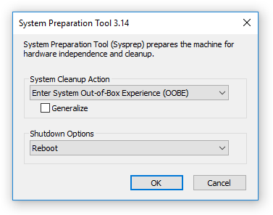

**What happens when you run Sysrep?**

The **Sysrep/**generalize command removes unique information from a windows installation so that **you** can safely reuse that image on a different computer. Once **you run Sysrep,** the computer will shut down after a few moments of processing the changes.

**What is mean by Storage Management Initiative Specification (SMI-S)?**